Disk Image Utility
8 Dec 2025
Darrell Pelan
Rev 2.4

Table of Contents
Introduction 2
Supported File Types 2
Home Screen 3
Windows 3
Function Buttons 4
Folder 4
File List 4
Extract 4
View 5
Delete 5
IMD/IMG Convert 5
H8D Convert to Soft Sector 5
Add CP/M / Add MS-DOS / HDOS (IMG and H8D only) 5
Create an Empty File 5
Appendix 7
Debug Mode 7
Disk Format Details 8
CP/M formats 8
HDOS Formats 9
Z100 CP/M Format 10
DOS Formats for Z-100 (FAT 12 Only) 10
DOS Formats (FAT 12 Only) 10
File Conversion Notes 10
Change Log 10

Introduction

Disk Image Utility is designed to support using Flash Floppy or HxC flashed Gotek drives with Heathkit 1980 era computers. It supports the native disk formats using IMG files and allows you to extract and add files from your PC to the disk image file. It currently supports CP/M, HDOS and MS-DOS FAT 12 formats used by the H-8, H-89, Z-100, RC2014, and Small Z-180. Version 2.4 adds CP/M support for NCR Deskmate systems.

If you want to copy files between images you must first extract the file and then insert the file in another image. This process is explained in the Function Button section below.

Disk Image Utility (DIU) can also create blank disk images in several CP/M, HDOS and MS-DOS formats which you can use in a Flash Floppy or HxC flashed Gotek. Disk Image Utility also supports adding files to these images.

DIU uses a combination of disk image size and disk type markers to determine the disk operating system type. Heathkit CP/M disks uses a file type marker at byte 5 in the first sector. HDOS has other markers in the image. NCR format disks have the characters “NCR” starting at byte 0A hex. MS-DOS format disks filenames need to end in “.DOS.IMG”. While DIU could determine if a disk is MS-DOS format, Flash Floppy drives are not able to distinguish between CP/M, HDOS, and MS-DOS formats that are the same size and sector sizes are all different.

DIU now runs under Linux, thanks to user input.

Installation
- Windows
  - Copy the Disk Image Utility .EXE file to any directory
  - Create a shortcut
  - Add the shortcut to the Start menu
- Linux
  - Install Mono if you don't have it already.
    - apt install mono-runtime
  - Make sure DiskUtility.exe is executable.
    - chmod +x DiskUtility.exe
  - Move the executable to a directory in your PATH with the name "diu".
    - mv DiskUtility.exe /usr/local/bin/diu

Supported File Types
The table below summarizes the capabilities for each file type. There is no need to convert an H8D file to IMD since the HxC Floppy Emulator supports the H8D format. IMD formats are converted to IMG. IMG files are converted to IMD.

Image | Directory | Extract | View | Insert | Delete | Convert Format
H8D | Y | Y | Y | Y | Y | To IMG
IMD DOS |  |  |  |  |  | To IMG
IMD CP/M | Y | Y |  |  | N | To IMG
IMD HDOS | N | N |  |  | N | To IMG
IMG CP/M | Y | Y | Y | Y | Y | To IMD
IMG DOS | Y | Y | Future | Y | Future | To IMD
IMG HDOS | Y | Y | Y | Y | Y | To IMD
 | Feature not supported
 | Note IMG DOS files must end in "DOS.IMG"

Home Screen

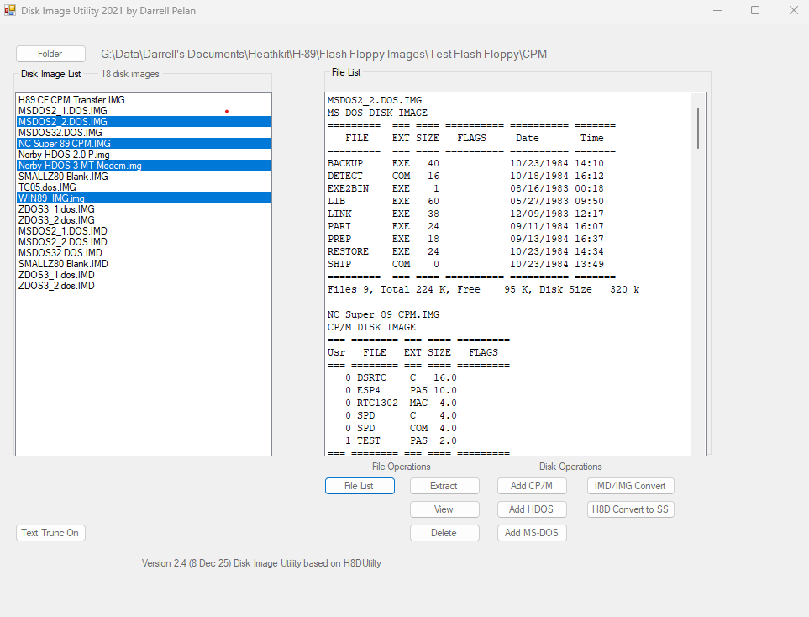

Windows
The Disk Image List shows the disk images in the target directory. Disk Image Utility starts in the last target directory used by the program. You can change the target directory using the Folder button. If you add files to the directory after starting DIU, you can refresh the Disk Image List by clicking Folder and OK.

The File List box shows the files in the images currently selected in the Disk Image List box when you click the File List button. If no images are selected, all file images are processed. CP/M file lists show the user area and status flags for each file. MS-DOS files show the flags, date and time for each file. Sub-Directories are only supported one level deep. Files in a sub directory of a sub directory will not display and cannot be extracted.

The File List window supports copying the file listing by left clicking with your mouse and then pasting the information in another application. There is no indication that the list copy occurred when you left click in the window.

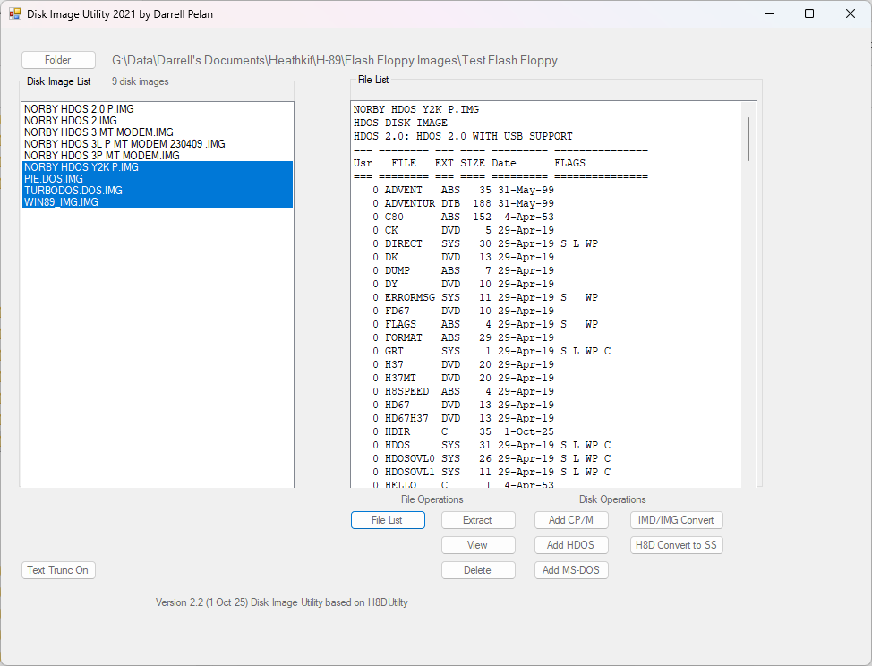

Function Buttons

Folder
Selects the working folder for the Disk Images.

File List
Displays the files in each disk image selected in the Disk Image List. If no images are selected, all images in the Disk Image List window are processed. The User Area and flags for each file are displayed for CP/M and HDOS images. DOS files show the flags, date, and time. Disk Image Utility will display the contents of a sub directory but not sub directories in the sub directory.

File List does not currently support DOS IMD images.

Extract
Extracts selected files in in the File List window. If no file is selected, Disk Image Utility will offer to extract all files. Extracted files are placed in a directory in the Disk Image List target folder created from the Disk Image file name with “_Files” appended.

Extract does not currently support DOS IMD images

View
Displays text in the first selected file. Currently, only CP/M and HDOS formats in IMG and H8D are supported.

Delete
Currently only supported under HDOS and CP/M.

IMD/IMG Convert
Converts IMG files to IMD format. You can then use HxC Floppy Emulator to convert the image to HFE format for use on HxC flashed Gotek drives. Disk images need to end in DOS.IMG for Disk Image Utility to properly recognize the image for conversion.

Converts IMD files to IMG file format. DOS files need to end in DOS.IMD for Disk Image Utility program to properly recognize the image as a DOS file. The file name does not impact the conversion from IMD to IMG.

You will need to select Folder and the click Ok to rescan the folder to see the new files.

H8D Convert to Soft Sector
Converts H8D files to IMG file format. The disk type byte at location 5 in sector 1 is updated to 0x60 to represent a 100k SS disk format. You will need to select Folder and the click Ok to rescan the folder.

Add CP/M / Add MS-DOS / AddHDOS (IMG and H8D only)
Opens a new window That allows you to create blank images in several formats. When opened using Add CP/M or HDOS, only non MS-DOS files are displayed in the Disk Image List. Not surprisingly, when opened with the Add MS-DOS button, only MS-DOS files are displayed. Image buttons not related to the select DOS are disabled. MS-DOS file images must end in “.DOS.IMG” to be properly recognized by DIU and Flash Floppy Goteks.

Double clicking on a file in the Disk Image List opens a new directory window to select individual files to add to the image.

Create an Empty File

Clicking on the button will create the format shown on the button. After the image is created, a new directory window will open to add files to the image. HDOS images give you an opportunity to change the Disk label from the default. If you only want the empty file, simply close the window. DIU will automatically rescan the directory for available disk images.

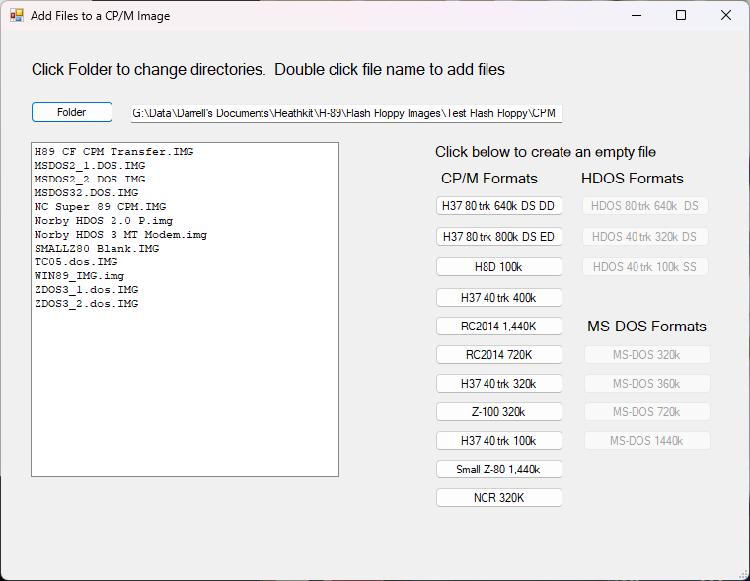

Appendix

Debug Mode (CP/M only)
- Debug mode is available with the command line option ‘D’. You can create a shortcut to the application and then append D to the Target string ("G:\Your Path\DiskImageUtility 2.4.exe" D) to start DIU in debug mode.
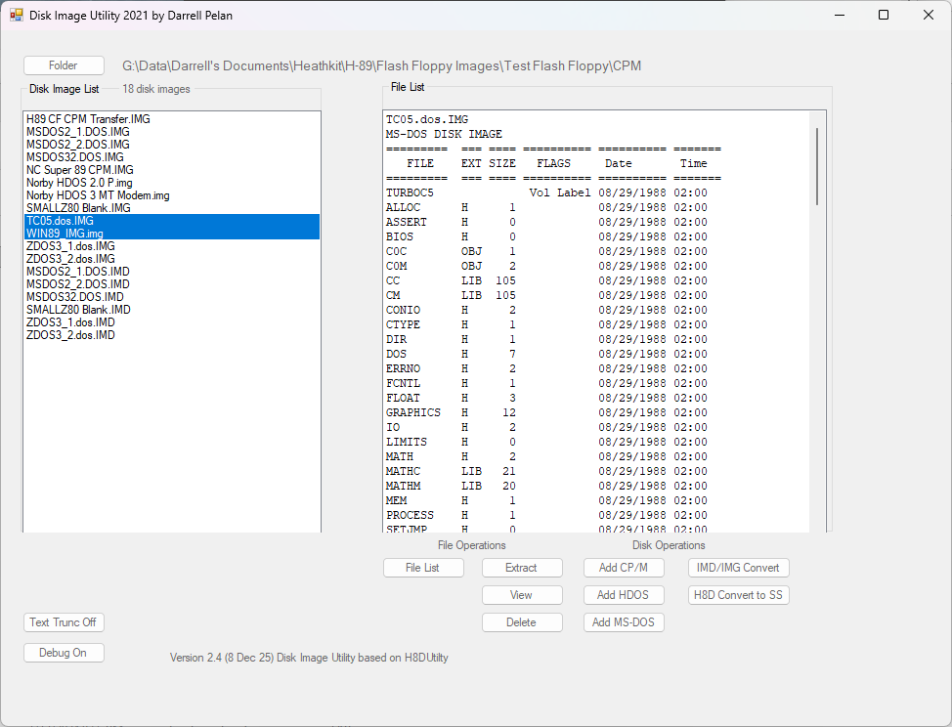
- With the command line option, the Debug Button toggle is enabled. You can enable the feature as needed with the toggle button.
- When you generate a file list, the Debug Window appears. It lists all the Allocation Blocks used by each program and will tell you if there are any duplicate assignments.
- You can copy the list in the Window using a mouse and Ctl-C
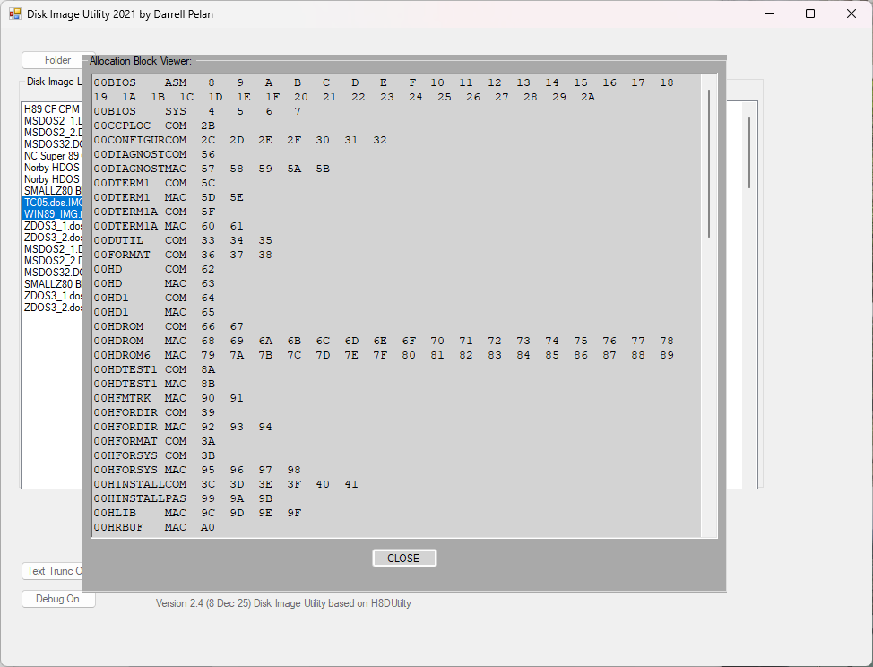

Disk Format Details

DIU will convert images to and from IMD to IMG. DIU only updates .IMG files.

CP/M formats
Heathkit CP/M disk images have an ID marker in byte 5 of the first sector on the disk.
Disk ID Marker | Sectors per Track | Sector Size | # Tracks | # Heads | Disk Size | File Extension | Computer
0xff | 18 | 512 | 80 | 2 | 1,474,560 | IMG | H89/H8
0x6f | 5 | 1024 | 80 | 2 | 819,200 | IMG | H89/H8
0x6b | 16 | 256 | 80 | 2 | 655,360 | IMG | H89/H8
0x67 | 5 | 512 | 80 | 2 | 409,600 | IMG | H89/H8
0x62 | 16 | 256 | 40 | 2 | 327,680 | IMG | H89/H8
0x63 | 9 | 512 | 40 | 2 | 368,640 | IMG | H89/H8
0x60 | 10 | 256 | 40 | 1 | 102,400 | IMG | H89/H8
0xE5 | 10 | 256 | 40 | 1 | 102,400 | H8D | H89/H8
0x00 | 10 | 256 | 40 | 1 | 102,400 | H8D | H89/H8
N/A | 18 | 512 | 80 | 2 | 1,474,560 | IMG | Small Z80
N/A | 9 | 512 | 80 | 2 | 737,280 | IMG | RC2014

HDOS Formats
Sectors per Track | Sector Size | # Tracks | # Heads | Sector Per Group | # Groups | Disk Size | File Extension
10 | 256 | 40 | 1 | 2 | 400 | 102,400 ** | IMG
16 | 256 | 40 | 2 | 6 | 1,278 | 327,680 | IMG
16 | 256 | 80 | 2 | 10 | 2,550 | 655,360 | IMG
** 100k size need additional work

Z100 CP/M Format
Disk ID Marker | Sectors per Track | Sector Size | # Tracks | # Heads | Disk Size | File Extension
0x23 | 8 | 512 | 40 | 2 | 327,680 | IMG

DOS Formats for Z-100 (FAT 12 Only)
Disk ID Marker | Sectors per Track | Sector Size | # Tracks | # Heads | Disk Size | File Extension
0xfd | 8 | 512 | 40 | 2 | 327,680 | DOS.IMG
0xff | 9 | 512 | 40 | 2 | 368,640 | DOS.IMG
0xf9 | 8 | 512 | 80 | 2 | 655,360 | DOS.IMG

DOS Formats (FAT 12 Only)
Disk ID Marker | Sectors per Track | Sector Size | # Tracks | # Heads | Disk Size | File Extension
0xf0 | 18 | 512 | 80 | 2 | 1,457,664 | DOS.IMG
0xf9 | 9 | 512 | 80 | 2 | 737,280 | DOS.IMG
0xf9 | 15 | 512 | 80 | 2 | 1,228,800 | DOS.IMG
0xff | 9 | 512 | 40 | 2 | 368,640 | DOS.IMG
- Note: DIU uses file size and Disk ID Marker (Media Description) to determine the correct disk parameters

File Conversion Notes

- Dunfield IMD files image skew matches physical disk. For an 800k disk, the first sector is 3.
- MS-DOS IMD disk has skew = 1
- IMG files are sequential order, skew = 1
- IMG conversion to IMD keeps skew = 1
- IMD conversion to IMG changes skew to 1

Change Log
- 1.1e
  - Added code for Livingston Logic Labs for H8D
  - Added IMG to IMD conversion
  - MessageBox Title Update. Changed Disk Utility to Disk Image Utility
- 1.1f
  - Corrected program exception error when adding files
- 1.1g
  - Changed IMD conversion to report a fatal error if the number of sectors per track changes between tracks.
  - Added ability to handle IMD cylinder map data (ignore it).
  - Delete converted file if an error occurs. Improved file conversion abort code.
- 1.2
  - Added HDOS Support
  - Supports both HDOS 3 and HDOS 2 disks
- 1.2a
  - Added support for MS-DOS 1.2MB
  - Added HDOS file delete
  - Added support for .H37 files with disk information at the end of the file name.
- 1.2b
  - Fixed bug in CP/M extract caused by added support for .H37 files.
- 1.2c
  - Added support for RC2014 CP/M format
- 1.2c1
  - Mostly fixed issue with CP/M disk definition table caused by 1.2c
- 1.2c2
  - Finally fixed CP/M disk definition table caused by 1.2c (mismatch on disk creation button)
- 1.2.d
  - Added ability to change disk label when creating HDOS disk image
  - Disabled buttons on Image creation page not related to current DOS selection
- 1.2d1
  - Fixed ^Z detection for text files truncating binary files
- 1.2e
  - Added on/off button for ^Z feature
- 1.2f
  - Fix Create 720k MS-DOS disk resulting in 1200k image
  - Fix Large IMD file treated like CP/M disk
  - Exit Insert function after Disk Full error message, so you don't keep processing files
  - After adding a new disk, clear File List
  - Clear File List on Folder Change
  - Remember last location you added files
  - Create a folder for each user area when extracting CP/M files
  - Added 320k Floppy disk image capability
- 2.0
  - Change IMD to IMG conversion to allow for SPT changes on different tracks
  - Corrected bug on RC2014 disk creation where the create function wasn’t called
- 2.1
  - Added 1,440k format for RC2014
- 2.2
  - Corrected HDOS date format updates in the directory to match Stan Webb’s Y2K format.
Year 00-99 Mon 1-12 Day 1-31
15-----------9 8------5 4--------0
| 7-bits | 4-bits | 5-bits |
- Bugs
  - Disc image TC05.DOS.IMG doesn't display directory correctly

- 2.4 NCR Branch
  - Add support for NCR 320k CP/M format
  - Corrected bug in CP/M disk directory read function to test filename in upper case for IMG
  - hackerb9 pull request - create .exe that works on Windows and Linux
  - hackerb9 pull request Save settings C# way
- 2.4 CPM-Erase
  - Added debug code to display the Allocation Blocks used by a CP/M file image
  - Enabled command line startup with 'D' to enable debug feature.
  - Added CP/M erase capability
  - Updated InsertFileHdos() to use var maxSector in place of LastGroupSector due to scope concern. LastGroupSector is used in class DirList
  - Corrected ReadHdosDir so that correct image size is returned
  - Corrected MS-DOS subdirectory processing to reset subDir Flag to false
  - Cleaned up File List Box Formatting related to subdirectories and Volume labels
  - Scans source directory after adding files to an image

